Driffield & Rural Ward and
East Wolds & Coastal Ward Update -
September 2021 Issue

Meet Your Team

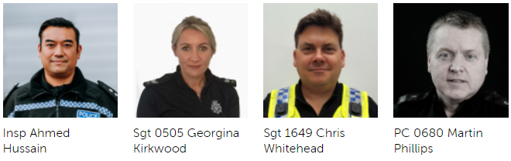

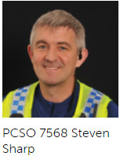
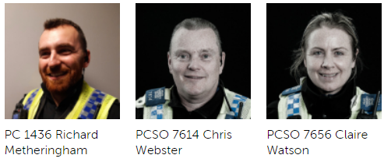

Detailed crime and ASB data for your area can be obtained by visiting www.police.uk and entering your postcode into the ‘What’s happening in your area?’ section.

For current information and guidance on Covid-19 please visit https://www.gov.uk/coronavirus. This is a ‘one stop shop’ for Covid-19 which is constantly being updated with the latest guidance from the government and health officials. Further information and links can be found on our website by visiting https://www.humberside.police.uk/coronavirus-advice-and-information

If after viewing the current information and guidance you still have concerns in relation to an individual, business or group of people not following the rules relating to Covid breaches please report via 101.
Can I also ask that if you become aware of persons living in your communities that you deem are vulnerable or isolated who are not receiving any support from Government agencies or volunteer organisations you please let us know via our email address:
Communities-BridlingtonTeamALLSTAFF@humberside.pnn.police.uk

- What’s Happening In Your Area? Review – Below last months

Burglary – Residential and commercial
There has been an increase of residential and commercial burglaries in the Driffield and surrounding areas over the past month. Many of these have been to outbuildings and sheds. We would ask that you review your security arrangements. We are very conscious that Harvesting time is a very busy period for many of you but this can mean easy pickings for an opportunist thief. Your local officers will be patrolling vulnerable areas but ask that you report any suspicious activity at the time via 101 or 999 if urgent.
Shop Theft
Reports of shop thefts had considerably reduced this month however we will continue working with local retail premises to ensure that best evidence is gained in order for us to deal with the offenders more effectively. We will continue to utilise ShopWatch to alert more stores to suspects.
Drug Use and dealing
We will continue to developing intelligence and where appropriate obtain warrants and execute them. Our work with Bridlington officers will only have a positive ‘knock on’ effect in our Towns and Villages.
Humbertalking
Humber Talking is still being undertaken in the Driffield area. We will be adhering to Social distancing guidance and will not be entering houses but speaking to members of the public who want to take part on their doorsteps. If you would rather participate online and highlight any issues you think the Police should be dealing with please visit the website www.mycommunityalert.co.uk/humbertalking your responses help us better understand our area and prioritise issues to be tackled.

- Meet your officers –

Rural surgeries are set to continue in September with the local Community team pitching up in various locations around the Driffield area, giving general crime prevention and advice on policing matters. We will continue to update Facebook and Twitter with dates as they become available. Come and see us!

Social distancing and Covid protocols will be in place.

Stay informed through our social media channels, find us on Twitter, Facebook and Instagram @humberbeat. For incidents that don’t require an immediate response call our non-emergency 101 line. You can also report non-emergency crimes online via our reporting portal. In an emergency always dial 999.

Police Station Front Counters – WE ARE OPEN

In line with government advice, we are making some changes to ensure that we can maintain our normal level of service, whilst also practising social distancing to keep our staff and the public safe.

We are asking you to only enter one of station front counters for one of the following reasons:

- If you have a legal requirement to do so – for example, answering bail

- If you are collecting property that you have been contacted about

- If you urgently require our assistance

If you do fit into one of the criteria above then we are asking you to follow the direction of our front counter staff once you enter to ensure social distance guidance is followed. Otherwise you can report a variety of matters via the Humberside Police Web-site or by calling 1010

- Crime News and Appeals

Local News – Review last months
We are investigating reports of a number of Burglaries in the Driffield Town area namely Bracken Road, Woldholme Avenue and Hudson Drive.

The incidents occurred between 2200hrs on 10/07/2021 and Sunday 11/07/2021. The offender(s) approached rear garden sheds and took Mountain Bikes which were secured and from another shed a Motor cross bike. If you saw anyone acting suspiciously in the area around this time or have information on the whereabouts of the stolen property, or have any information about the offenders please contact the police on the new telephone number 101 quoting Log number 0182 11/07/2021
On the 23rd of July an attempted shed burglary was reported on Eastfield Road, Driffield and on the East Wolds and Coastal Ward on the 25th a Honda Motor Cycle was stolen from a garage on North Townside Road, North Frodingham. A window was smashed and electric doors operated to remove the vehicle.

Tack was stolen from a premises in Fraisthorpe on the 5th and The Great Wall Chinese in Beeford was subject to a burglary on the 13th. This is linked to offences that occurred the same night in Hornsea for which we have a suspect. On the 28th a farm office was entered on Catfoss Lane and a drill stolen.

Your local officers will be by default patrolling vulnerable areas but ask that you report any suspicious activity at the time via 101 or 999. We also remind you to lock all windows and doors in the warmer weather when leaving your property.

Please also consider fitting an alarm to sheds and garages that house high value items.
We welcome contact from you to review your security arrangements. Please pop into your local police station or contact us via email at
Communities-BridlingtonTeamALLSTAFF@humberside.pnn.police.uk

The Community Team will be patrolling rural locations now that the crops are starting to be harvested with the possibility of Hare Coursing starting up.

We attended the Driffield Show which was a great success over the two days, offering crime prevention advice and answering any questions around policing matters. Officers also took part in the Great Driffield Mascot race.

Warning after doorstep scams and burglaries
We have received two reports of concern from elderly people in the East Riding. They have reported bogus callers which have led to theft from their homes in Hornsea and Goole.
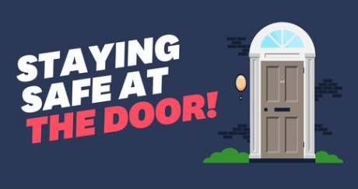
In both cases a man was reported to have cold-called at the address discussing repairs to their drives or gardens. After the caller left, the elderly homeowners have reported that money has been taken from within the home.
Enquiries into the reports are underway and we ask anyone with information about this offence to call us on 101 quoting reference 16/84295/21 or call Crimestoppers anonymously on 0800 555 111.
We would like to take the opportunity to remind people about the potential dangers of door to door ‘scammers’ or ‘bogus callers’ and ask for people to speak to their elderly friends or relatives about the dangers.

Our advice would be:

- DO NOT answer the door to anyone you don't know or who cannot provide valid ID.
- DO NOT buy goods from door step sellers, the quality of the goods cannot be guaranteed and if there is a problem with the item you have no comeback or way to return items.
- Age UK also have some very good advice about doorstep sellers at https://www.ageuk.org.uk/information-advice/money-legal/scams-fraud/doorstep-scams/
- There are many different types of doorstep scams, some of the most common ones include:
- Rogue traders: A cold-caller may offer you a service you don’t really need. They may claim to have noticed something about your property that needs work or improvement, such as the roof, and offer to fix it for cash or an inflated price.
- Bogus officials: People claim to be from your utility company as a way of gaining access to your home. Always check the ID of any official, and if they're genuine they won't mind waiting while you check.
- Fake charity collections: A fraudster may pretend they're from a charity and ask you to donate money, clothes or household goods. Legitimate charities will all have a charity number that can be checked on the Charity Commission website.
- Made-up consumer surveys: Some scammers ask you to complete a survey so they can get hold of your personal details, or use it as a cover for persuading you to buy something you don’t want or need.
- Hard luck stories: Someone may come to your door and ask you to help them out with cash, ask to use your telephone or claim they're feeling unwell. The story is made up and intended to con you out of your money or gain access to your home.

- If you see or hear anything suspicious or if you think you have been a victim of this type of crime please call us on 101 to talk to us about what’s happened or call Crimestoppers anonymously on 0800 555 111.. We want to help you and to help prevent anyone else becoming a victim.


For further crime prevention advice and general information please take a look at our website by visiting. https://www.humberside.police.uk/information-advice. You will also find the latest news & appeals, and find out more about My Community Alert.

“My Community Alert” is a free messaging system operated by Humberside Police and Humberside Fire & Rescue Service, giving you live information about incidents happening in your area. Choose how you receive messages, by either phone or email, how often you want to hear from us and about the issues that matter to you. When something happens that you’ve told us you want to hear about, your local officer will send you the details, whether that’s notice of a road closure due to a collision or a burglar who has been caught in a nearby garden. Subscribe to My Community Alert to be the first to know about issues that might affect you or your family. Sign up for free on mycommunityaltert.co.uk to start receiving real time updates now.

Also follow us on www.twitter.com/@Humberbeat_ERYN

AREA COVERED BY DRIFFIELD & RURAL TEAM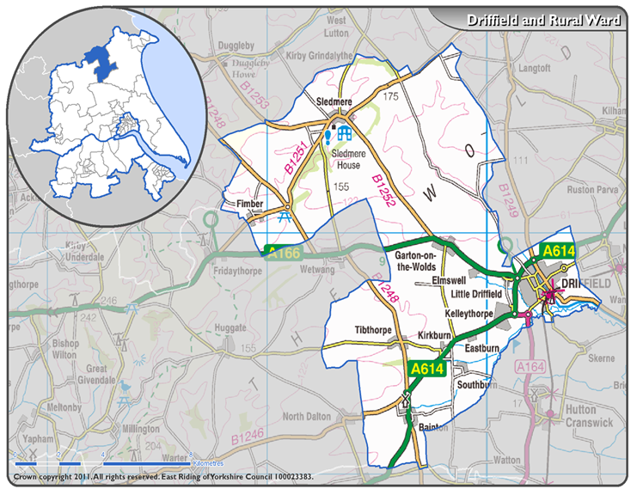

AREA COVERED BY EAST WOLDS & COASTAL TEAM

