Driffield & Rural Ward and
East Wolds & Coastal Ward Update -
August 2021 Issue

Meet Your Team

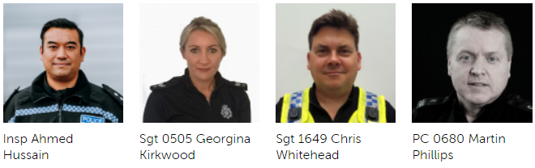

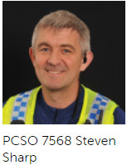
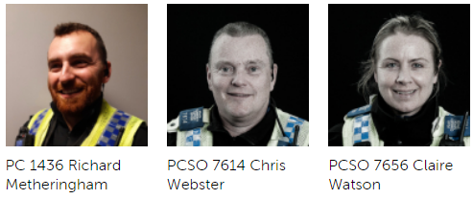

Detailed crime and ASB data for your area can be obtained by visiting www.police.uk and entering your postcode into the ‘What’s happening in your area?’ section.

For current information and guidance on Covid-19 please visit https://www.gov.uk/coronavirus. This is a ‘one stop shop’ for Covid-19 which is constantly being updated with the latest guidance from the government and health officials. Further information and links can be found on our website by visiting https://www.humberside.police.uk/coronavirus-advice-and-information

If after viewing the current information and guidance you still have concerns in relation to an individual, business or group of people not following the rules relating to Covid breaches please report via 101.
Can I also ask that if you become aware of persons living in your communities that you deem are vulnerable or isolated who are not receiving any support from Government agencies or volunteer organisations you please let us know via our email address:
Communities-BridlingtonTeamALLSTAFF@humberside.pnn.police.uk

- What’s Happening In Your Area?

Burglary – Residential and commercial
There has been an increase of residential and commercial burglaries in the Driffield and surrounding areas over the past month. Many of these have been to outbuildings and sheds. We would ask that you review your security arrangements. We are very conscious that Harvesting time is a very busy period for many of you but this can mean easy pickings for an opportunist thief. Your local officers will be patrolling vulnerable areas but ask that you report any suspicious activity at the time via 101 or 999 if urgent.
Shop Theft
Reports of shop thefts had considerably reduced this month however we will continue working with local retail premises to ensure that best evidence is gained in order for us to deal with the offenders more effectively. We will continue to utilise ShopWatch to alert more stores to suspects.
Drug Use and dealing
We will continue to developing intelligence and where appropriate obtain warrants and execute them. Our work with Bridlington officers will only have a positive ‘knock on’ effect in our Towns and Villages.
Humbertalking
Humber Talking is still being undertaken in the Driffield area. We will be adhering to Social distancing guidance and will not be entering houses but speaking to members of the public who want to take part on their doorsteps. If you would rather participate online and highlight any issues you think the Police should be dealing with please visit the website www.mycommunityalert.co.uk/humbertalking your responses help us better understand our area and prioritise issues to be tackled.

- Meet your officers –

Rural surgeries are set to continue in August with the local Community team pitching up in various locations around the Driffield area, giving general crime prevention and advice on policing matters. We will continue to update Facebook and Twitter with dates as they become available. Come and see us!

Social distancing and Covid protocols will be in place.

Stay informed through our social media channels, find us on Twitter, Facebook and Instagram @humberbeat. For incidents that don’t require an immediate response call our non-emergency 101 line. You can also report non-emergency crimes online via our reporting portal. In an emergency always dial 999.

Police Station Front Counters – WE ARE OPEN

In line with government advice, we are making some changes to ensure that we can maintain our normal level of service, whilst also practising social distancing to keep our staff and the public safe.

We are asking you to only enter one of station front counters for one of the following reasons:

- If you have a legal requirement to do so – for example, answering bail

- If you are collecting property that you have been contacted about

- If you urgently require our assistance

If you do fit into one of the criteria above then we are asking you to follow the direction of our front counter staff once you enter to ensure social distance guidance is followed. Otherwise you can report a variety of matters via the Humberside Police Web-site or by calling 1010

- Crime News and Appeals

Local News
We are investigating reports of a number of Burglaries in the Driffield Town area namely Bracken Road, Woldholme Avenue and Hudson Drive.

The incidents occurred between 2200hrs on 10/07/2021 and Sunday 11/07/2021. The offender(s) approached rear garden sheds and took Mountain Bikes which were secured and from another shed a Motor cross bike. If you saw anyone acting suspiciously in the area around this time or have information on the whereabouts of the stolen property, or have any information about the offenders please contact the police on the new telephone number 101 quoting Log number 0182 11/07/2021
On the 23rd of July an attempted shed burglary was reported on Eastfield Road, Driffield and on the East Wolds and Coastal Ward on the 25th a Honda Motor Cycle was stolen from a garage on North Townside Road, North Frodingham. A window was smashed and electric doors operated to remove the vehicle.

Tack was stolen from a premises in Fraisthorpe on the 5th and The Great Wall Chinese in Beeford was subject to a burglary on the 13th. This is linked to offences that occurred the same night in Hornsea for which we have a suspect. On the 28th a farm office was entered on Catfoss Lane and a drill stolen.

Your local officers will be by default patrolling vulnerable areas but ask that you report any suspicious activity at the time via 101 or 999. We also remind you to lock all windows and doors in the warmer weather when leaving your property.

Please also consider fitting an alarm to sheds and garages that house high value items.
We welcome contact from you to review your security arrangements. Please pop into your local police station or contact us via email at
Communities-BridlingtonTeamALLSTAFF@humberside.pnn.police.uk

The Community Team will be patrolling rural locations now that the crops are starting to be harvested with the possibility of Hare Coursing starting up.

We attended the Driffield Show which was a great success over the two days, offering crime prevention advice and answering any questions around policing matters. Officers also took part in the Great Driffield Mascot race.

Message from the Rural Task Force - As the harvest gets in full swing in our rural areas we are reminding people to keep their properties and equipment safe and secure.
Rural Task Force officer Josh Fawcett said, “At this time of year our farmers and rural communities are so busy bringing in the harvest and tending their crops that they can often forget to make sure their properties and equipment are properly secure.
“Their machinery is a massive investment and so we want to remind people to keep it safe and out of the way of opportunist or targeting thieves.
“One of the key items targeted by thieves across the country are Tractor GPS and Navigation equipment.
Watch our crime prevention video here: https://youtu.be/-stWJnZzlLg
“Here are some tips to prevent these being stolen.
MARK IT, REMOVE IT, LOCK IT
Tractor GPS Screens
Remove screens when not in use – ensure they are left in a safe and secure location.
Mark screens using Forensic Marking and use the provided stickers to advertise forensic marking is in use
Record serial numbers
Tractor GPS Receivers
If not in use, disconnect, remove and secure in a safe location
Remove from roof if not in use and tractor is being used on road – this will prevent advertising the fact you have a receiver.
Ensure the software is up to date, and marked with security warning stickers
Consider securing the tractor in a locked alarmed shed
Record serial numbers
“Please also make sure your device is properly insured as it may need to be a separate item on your insurance, especially once removed from machinery.
“We would also advise people to consider installing CCTV, intruder alarms, security lighting and boundary security (entrance gates/fencing) around your property to provide formal surveillance and target harden the most vulnerable areas.
“We cannot physically be everywhere at the same time and our communities are our eyes and ears in the countryside. They know when something they see isn’t right. We want them to call us about any suspicious activity they see. Please report this to police immediately on 999 if there is a crime in progress or 101 for non-emergency incidents.
“For more information about how to protect your farm, properties and equipment please head over to our website where you will find lots of useful information https://www.humberside.police.uk/wildlife-and-rural-crime."
We also have a rural crime prevention booklet which can be obtained through the website as a PDF or as a booklet via our Rural Task Force SPOCRuralandWildlifeCrime@humberside.pnn.police.uk
#RuralCrime #NFU #Farmwatch #RuralTaskForce

Cannabis Edibles – Risk to health

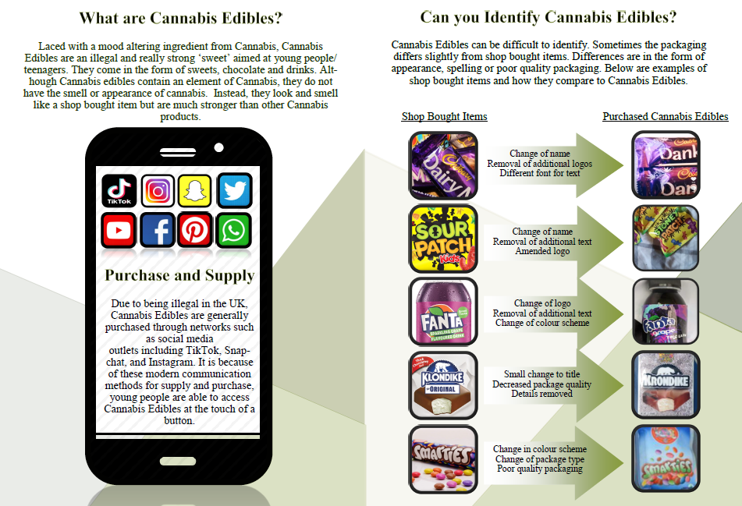

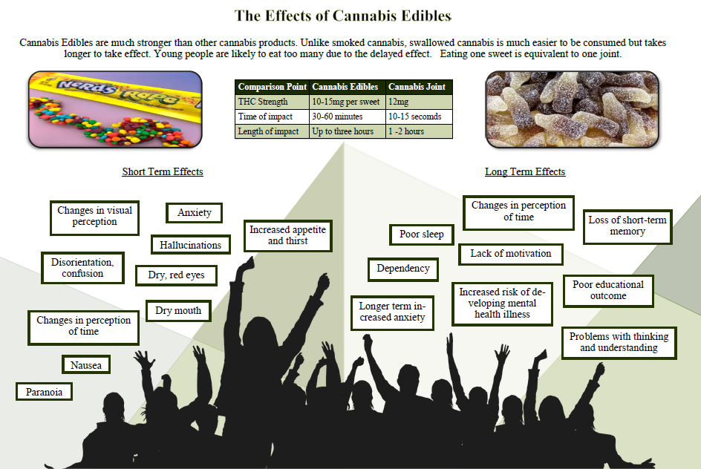

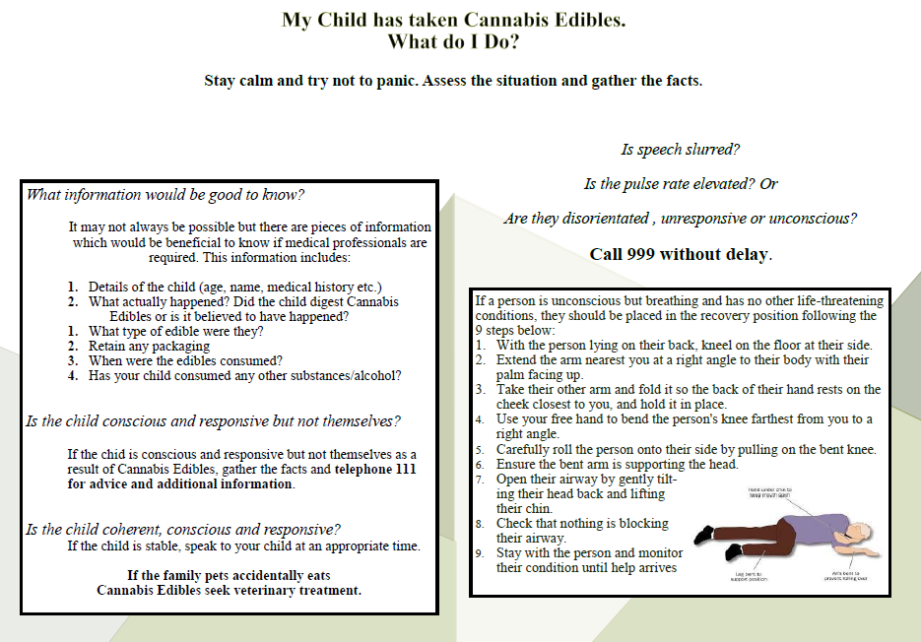

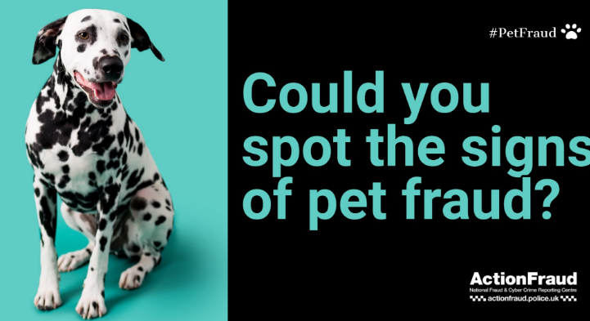
Fraud Alert – Buying a pet online

Data from Action Fraud, the national reporting centre for fraud and cyber crime, reveals that £2,638,323 was lost by prospective pet owners in the 2020/21 financial year, aft er they put down deposits for pets they saw advertised online – an increase of over 20 per cent compared to the previous financial year.
Capitalising on the rise in people getting pets due to the national lockdowns caused by coronavirus, criminals have been posting fake adverts on social media, online marketplaces and specific pet-selling platforms.
Unsuspecting victims will be asked to pay a deposit for the pet without seeing it in person first, with many criminals using the restrictions caused by the pandemic as a reason why they cannot see the animal. After the initial payment is made, more and more funds will be requested to cover additional costs such as insurance, vaccinations and even delivery of the pet.
How to protect yourself
Do your research: if you’re making a purchase from a website or person you don’t know and trust, carry out some research first. Look up reviews of the website or person you’re buying from. If you’re purchasing an item from an online marketplace, you can view the seller’s feedback history before going ahead with the purchase.
Trust your instincts: if you’re unable to view the animal in person, ask for a video call. If you’re buying a young animal, make sure you’re able to see the mother and rest of the litter. Any responsible seller will understand why you want to view the animal in person. If the seller declines, challenge them on why. If you have any suspicions, do not pay any money until you’re certain it’s genuine.
Choose your payment method wisely: avoid paying by bank transfer. Credit card or payment services such as PayPal give you a better chance of recovering your money if you become a victim of fraud.
When things go wrong: Anyone can fall victim to fraud. If you think you’ve been a victim of fraud, contact your bank immediately and report it to Action Fraud online at actionfraud.police.uk or by calling 0300 123 2040.
Action Fraud also advises that the public follow the advice of the Take Five to Stop Fraud campaign to keep themselves safe from fraud.
- Stop: taking a moment to stop and think before parting with your money or information could keep you safe.
- Challenge: could it be fake? It’s okay to reject, refuse or ignore any requests. Only criminals will try to rush or panic you.
- Protect: if you think you’ve been a victim of fraud, contact your bank immediately and report it to Action Fraud online at actionfraud.police.uk or by calling 0300 123 2040.

Fraud Alert – Scam car insurance policies

Just 15% of people have heard of a ‘ghost broker’.* Do you know what one is?
Have you ever heard of a ‘ghost broker’? No, we are not talking about things that go bump in the night – this is a lot scarier. ‘Ghost brokers’ are fraudsters who sell fake or invalid car insurance policies. Victims are sold fake insurance documents for a policy that does not exist, or for a genuine policy that has been set up using false details to lower the price of the premium.
How do ‘ghost brokers’ operate?
Fraudsters lure victims in with the offer of cheaper insurance premiums, usually via social media or by word-of-mouth. These individuals or groups pose as middlemen for well-known insurance companies, claiming they can offer you legitimate car insurance at a significantly cheaper price.
This type of fraud is typically carried out either by forging insurance documents, falsifying your details to bring the price down, or by taking out a genuine policy for you but cancelling it soon after.
Often, the victim is not aware that they have been scammed until they are involved in an accident and try to claim on the policy.
Who do ‘ghost brokers’ target?
‘Ghost brokers’ tend to target vulnerable communities, including members of non-English speaking communities who may not have full knowledge of UK insurance and laws, as well as young people looking for cheaper insurance deals.
Last year, Action Fraud received 694 reports of ‘ghost broking’, with almost a third (29%) coming from victims aged 17-29. The reported losses for these victims alone totalled £113,500, with each individual losing an average of £559.
Figures also indicate that over half (58%) of all reports in 2020 were submitted by men.
What could happen if I drive without valid insurance?
As policies sold by ‘ghost brokers’ are either invalid, non-existent or fraudulent, this means that the driver is technically uninsured, meaning that you could face:
- £300 fixed penalty notice
- Six points on driving licence
- Vehicle being seized and crushed
How can I protect myself from ‘ghost brokers’?
There are simple steps that you can take to spot the signs of these scams and avoid being taking for a ride by ‘ghost brokers’:
- ‘Ghost brokers’ often advertise and communicate via social media, online forums and messaging apps. If a broker is only using a mobile phone or email as a way of contact, this can be a sign of this type of crime. Fraudsters do not want to be traced after they have taken money from their victims.
- They may also try to sell insurance policies through print adverts in pubs, clubs or bars, newsagents
- If a deal seems too good to be true, then it probably is. If you are not sure about the broker, check on the Financial Conduct Authority or the British Insurance Brokers’ Association website for a list of all authorised insurance brokers. You can also contact the insurance company directly to verify the broker’s details. You can also check to see if a car appears to be insured on the Motor Insurance Database website.
- If you think that you have been a victim of a ghost broker, you can report your concerns to Action Fraud at actionfraud.police.uk or on 0300 123 2040.
- You can also contact the Insurance Fraud Bureau via its confidential Cheatline on 0800 422 0421 or on the IFB website.


For further crime prevention advice and general information please take a look at our website by visiting. https://www.humberside.police.uk/information-advice. You will also find the latest news & appeals, and find out more about My Community Alert.

“My Community Alert” is a free messaging system operated by Humberside Police and Humberside Fire & Rescue Service, giving you live information about incidents happening in your area. Choose how you receive messages, by either phone or email, how often you want to hear from us and about the issues that matter to you. When something happens that you’ve told us you want to hear about, your local officer will send you the details, whether that’s notice of a road closure due to a collision or a burglar who has been caught in a nearby garden. Subscribe to My Community Alert to be the first to know about issues that might affect you or your family. Sign up for free on mycommunityaltert.co.uk to start receiving real time updates now.

Also follow us on www.twitter.com/@Humberbeat_ERYN

AREA COVERED BY DRIFFIELD & RURAL TEAM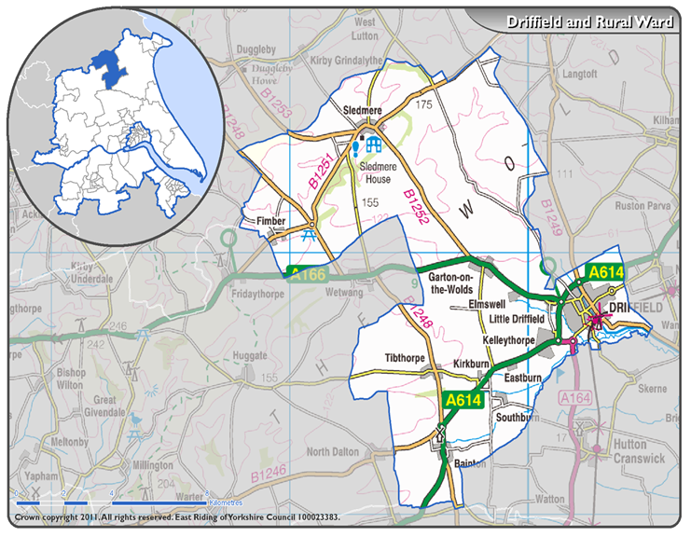

AREA COVERED BY EAST WOLDS & COASTAL TEAM

