Driffield & Rural Ward and
East Wolds & Coastal Ward Update -
November 2021 Issue

Meet Your Team

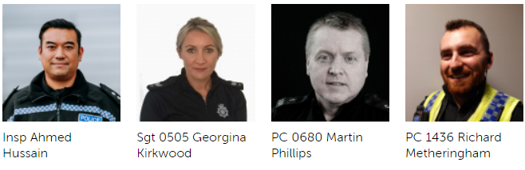

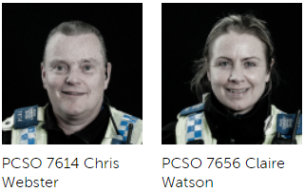
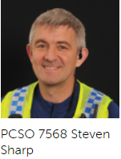

For current information and guidance on Covid-19 please visit https://www.gov.uk/coronavirus. This is a ‘one stop shop’ for Covid-19 which is constantly being updated with the latest guidance from the government and health officials. Further information and links can be found on our website by visiting https://www.humberside.police.uk/coronavirus-advice-and-information

If after viewing the current information and guidance you still have concerns in relation to an individual, business or group of people not following the rules relating to Covid breaches please report via 101.
Can I also ask that if you become aware of persons living in your communities that you deem are vulnerable or isolated who are not receiving any support from Government agencies or volunteer organisations you please let us know via our email address:
Communities-BridlingtonTeamALLSTAFF@humberside.pnn.police.uk

- What’s Happening In Your Area?

Shop Theft
This has been more notable in the larger retail outlets. Local officers will continue to engage with businesses to encourage new members to Shop Watch via WhatsApp. We will continue to work with businesses on how to produce “best evidence” when reporting crimes. Local officers will conduct high visibility patrols during business hours to deter shop thefts and look to update/improve the existing civic CCTV system.
Drug Use and dealing
We have seen an increase in intelligence around the supply and use of controlled substances within Driffield and surrounding areas. We will continue to obtain Search Warrants using intelligence gained from various sources. We will look to conduct a drugs dog operation / stop & search including licence premises and areas used for drug taking. We will conduct high visibility patrols in identified areas of drug misuse and deal with offenders accordingly enhancing the intelligence picture.
Rural Crime
As ASB, poaching and inquisitive crime increases due to various factors we will Increase high visibility patrols working with partner agencies including Farm Watch. We will ensure incidents are shared with the public using My Community Alert and conduct visits to rural businesses to promote crime prevention. We will continue to visit farms and locations of rural crime to obtain best evidence and promote crime prevention. Further high visibility night patrols to deter/disrupt/detect night time poaching are planned.
Humbertalking
Humber Talking is still being undertaken in the Driffield area. We will be adhering to Social distancing guidance and will not be entering houses but speaking to members of the public who want to take part on their doorsteps. If you would rather participate online and highlight any issues you think the Police should be dealing with please visit the website.
www.mycommunityalert.co.uk/humbertalking your responses help us better understand our area and prioritise issues to be tackled.

- Meet your officers –

We encourage everyone to follow Government Advice on Coronavirus at https://www.gov.uk/coronavirus

The Community team have no surgeries booked for the rest of the year however we will be at the Driffield Christmas Lights Switch on as well as all the Yuletide markets planned in the Driffield Town Centre, 26th of November, 28th of November and the 5th of December. Please come and talk to us for crime prevention advice, concerns you may have or just a chat!

Social distancing and Covid protocols will be in place.

Stay informed through our social media channels, find us on Twitter, Facebook and Instagram @humberbeat. For incidents that don’t require an immediate response call our non-emergency 101 line. You can also report non-emergency crimes online via our reporting portal. In an emergency always dial 999.

Police Station Front Counters – Driffield - WE ARE OPEN

Our normal opening hours are Tuesday, Wednesday, Thursday 9am-5pm (Closed 1-2pm).

- Local News

Detailed crime and ASB data for your area can be obtained by visiting www.police.uk and entering your postcode into the ‘What’s happening in your area?’ section.

Driffield officers continue to patrol areas that have reported high levels of Anti-social-behaviour. We are assisting the Rural Task Force with cross border night-time patrols as well as OP Galileo to deal with Hare Coursing offences and Rural Crime. We have had some positive results with several individuals dealt with for poaching offences and vehicles and dogs seized.

Officers have also been conducting foot patrol in Driffield town centre to combat seasonal shop theft. We have targeted offenders traveling in from surrounding areas and note a decrease in reported crimes.

Recent Humber talking has highlighted concerns from local residents with excess speed in Cranswick village. We have liaised with the Parish Council and will be conducting speed checks. Data will then be shared with Safer Roads who can then assess and consider further measures.

PCSO 7568 SHARP will continue using the Speed board and speed detection equipment at other areas highlighted by local people. If you have concerns in a particular location please contact us.

- News and Appeals

25/10/2021 - We are appealing for witnesses to a road traffic collision which happened at 11am on Monday 25 October 2021 on Main Street in Cranswick.

A Ford Journey green and white taxi left the road and collided with a lamppost. The driver is thought to have had a medical episode at the wheel and has been taken to hospital where he remains in a critical condition.

Anyone who saw the collision, or the vehicle prior to the incident that has not already spoken to us, is asked to call our non-emergency number 101 quoting log 152 of 25 October 2021.

19/10/2021 - Appeal for witnesses & drivers with dash-cams who may have been in the area of Carnaby Ind Est on Tues 19 Oct.
A trailer with a large quantity of steel was taken from a compound after it was broken into.
If you can help call 101 quoting reference 16/103689/21.

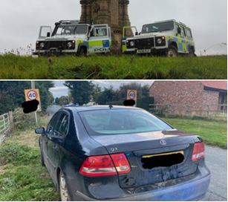
17/10/2021 - Following reports of illegal hare coursing in the Wetwang area yesterday, 3 males have been reported for poaching offences, vehicle seized & dogs seized. We will not tolerate wildlife crime & will always take positive action against those involved.

14/10/2021 - Arson to Straw Bales. During the early hours of Thursday 14th October approx 200 tons of Straw Bales were set alight between Wold Newton and Thwing, suspected deliberate Ignition.
Please can we ask the farming and rural community to remain extra vigilant around straw bales.
These incidents not only involve great risk to landowners, farmers and fire & rescue services who attend, but also result in huge financial impact.
Please report any suspicious activity to police on 999 for any incidents in progress or 101 for non-emergency incidents.

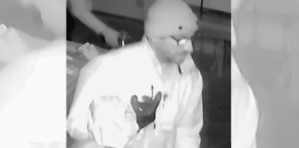
Appeal to ID man in connection with burglary in Driffield on Saturday 11 September 2021.

Can you help? Do you know this person? If you can help with our enquiries please call our non-emergency number 101 quoting reference 16/90812/21

Man appears in court following hare coursing charge – 13/10/2021

On Sunday 1 November 2020 a man was arrested on suspicion of hunting with dogs and subsequently charged after we received reports of hare coursing in the Rotsea area of East Yorkshire.

He was also charged in connection with a similar incident which occurred at Withernwick, East Riding of Yorkshire on Saturday 2 January 2020 .

Following on from this Paul Bowes (30) from Bishop Auckland was issued with an 18-week suspended sentence at Hull Magistrates Court yesterday (Tuesday 12 October).

Bowes will be required to complete 200 hours’ worth of unpaid work, he has also been disqualified from driving for a period of 12 months and disqualified for keeping animals for a period of 5 years.

In addition, Bowes was ordered to pay a total of £728 in costs and victim surcharge as punishment for his actions.

Police Sergeant Jenna Jones said: “I’m really pleased with the outcome at court yesterday (Tuesday 12 October). Hare coursing is a barbaric and bloodthirsty crime which often result in the majestic hare and other wildlife suffering horrific injuries or loss of life.

“Not only does our wildlife suffer, but it significantly impacts our rural and farming communities as crops, hedge and gates are often left damage as a result of these horrific crimes. The dogs involved in these incidents are often treated as “tools of the trade” and are overlooked as a family pet.

“Working in partnership with local farm watches alongside 26 other forces nationally under Operation Galileo we will continue with our proactive work in a bid to deter and stop offenders committing wildlife and rural crime.

“The result at court shows that offenders will be dealt with robustly and that we will not tolerate hare coursing in the Humberside Police area."

Advice from the Rural Task Force

Keep your farm safe:

FUEL THEFT

With the recent increases in fuel costs and limited supplies, fuel is a valuable item targeted by thieves. Help prevent fuel being stolen by taking some crime prevention measures.

☎ Report any suspicious activity
⛽ Keep vehicles in a secure area, preferably a garage, shed, or outbuildings.
⛽ Consider the use of locking fuel caps.
⛽ Re-fuel vehicles just before the planned journey rather than leaving a vehicle fully fuelled overnight.
🚜 Park vehicles in areas that are well lit so they can be observed easily.
📣 Consider the use of alarms. This could be on the vehicles themselves or for the perimeter of the parking/storage area.
⛽ Fit anti-syphoning devices.
📹 Install or confirm existing CCTV is fit for purpose, and train a camera on tanks and vulnerable vehicles.
⛽ Install cages and/or improve security that surrounds fuel storage tanks.
⛽ Consider using ‘bunded’ fuel tanks if your existing storage facility is not of that type.
⛽ Consider the deployment of fuel dyes.
🚜 Use defensive parking techniques, wherever possible park vehicles against solid objects on the fuel tank side to prevent access.
🔒 Do not leave keys in or near a vehicle, where they can be easily found.
👀 Arrange for checks of vehicles and premises outside of normal working hours.
🚫 Display signage to show security devices are fitted.

“We cannot physically be everywhere at the same time and our communities are our eyes and ears in the countryside. They know when something they see isn’t right. We want them to call us about any suspicious activity they see. Please report this to police immediately on 999 if there is a crime in progress or 101 for non-emergency incidents.

“For more information about how to protect your farm, properties and equipment please head over to our website where you will find lots of useful information https://www.humberside.police.uk/wildlife-and-rural-crime.

We also have a rural crime prevention booklet which can be obtained through the website as a PDF or as a booklet via our Rural Task Force SPOCRuralandWildlifeCrime@humberside.pnn.police.uk

Hare Coursing/Poaching

Lincolnshire Police Lead for Operation Galileo Chief Inspector Phil Vickers. “The big news for 2020/21 is bringing together the top 26 Hare Coursing forces across the country under the Op Galileo banner – We are now able to target offenders who cause greatest harm to our rural communities by sharing information and intelligence from across the whole of the UK.

“The National Wildlife Crime Unit (NWCU) continues to support us, and this year we are ready to use legislation in new ways against hare coursers, to seize property, assets and dogs to make hare coursing as difficult, and unattractive as possible. “

Humberside Rural Task Force will be leading our Operation supported by neighbourhood policing teams across the force area.

We ask our communities to contact us on 999 for crime in progress, 101 for suspicion activity/vehicles and for general heritage, rural and wildlife crime enquires via our email of SPOCRuralandWildlifeCrime@humberside.pnn.police.uk

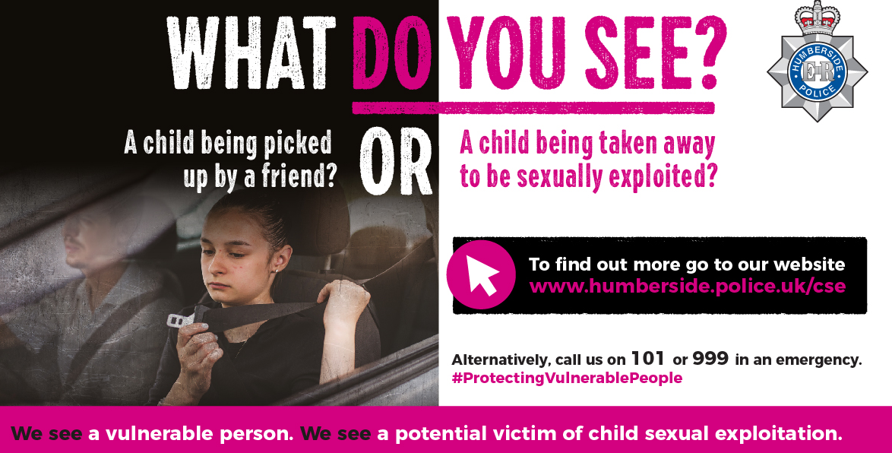
Campaign launched to protect more children from sexual exploitation
If you think about your idea of who a typical child sex offender is, or who the child that is being exploited sexually is, what comes to mind?

Age, nationality, ethnicity, gender, social and economic background. Sexual offenders and victims of child sexual exploitation don’t fall into any one category, and we want to break the pre-conceptions you may have from TV shows or the media of a ‘typical’ suspect and victim.

We have today, Monday 18 October, launched a campaign solely focussed on helping you more easily recognise the genuine signs that a child may be being exploited.

Child sexual exploitation (CSE) is an area which goes heavily unreported; it’s a hidden crime. We know it happens and is sadly not an issue unique to our area, but we want to raise awareness of some of the signs you may be able to spot, whether it’s your child or someone else’s, so that we can protect more children from the hands of sexual predators using them for their own personal gain.

Protecting vulnerable people has always been our number one priority, but if we don’t know something is happening, we can’t take action to stop it.

We are actively asking for your help in reporting any activity, online or physical, which concerns you. No matter how small, nothing is wasting our time, and it will be treated seriously. We have a dedicated team who focus solely on investigating CSE reports and all come to work every day with a goal of protecting children.

You can find out more about the signs to recognise and how you can report any suspicious people or behaviour here: https://www.humberside.police.uk/child-sexual-exploitation-cse

Over the coming weeks, you will see our ‘What do you see?’ adverts on social media, in businesses, on billboards and more. We encourage you to share these with your friends and family, so that collectively we can tackle CSE and safeguard children from harm’s way.

To report a crime in progress, always call 999. Call 101 for non-emergencies and to report any information, or you can call Crimestoppers anonymously on 0800 555 111.


For further crime prevention advice and general information please take a look at our website by visiting. https://www.humberside.police.uk/information-advice. You will also find the latest news & appeals, and find out more about My Community Alert.

“My Community Alert” is a free messaging system operated by Humberside Police and Humberside Fire & Rescue Service, giving you live information about incidents happening in your area. Choose how you receive messages, by either phone or email, how often you want to hear from us and about the issues that matter to you. When something happens that you’ve told us you want to hear about, your local officer will send you the details, whether that’s notice of a road closure due to a collision or a burglar who has been caught in a nearby garden. Subscribe to My Community Alert to be the first to know about issues that might affect you or your family. Sign up for free on mycommunityaltert.co.uk to start receiving real time updates now.

Also follow us on www.twitter.com/@Humberbeat_ERYN

AREA COVERED BY DRIFFIELD & RURAL TEAM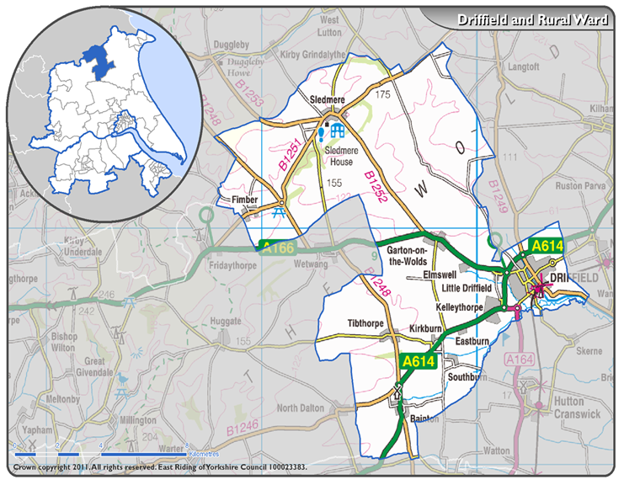

AREA COVERED BY EAST WOLDS & COASTAL TEAM

